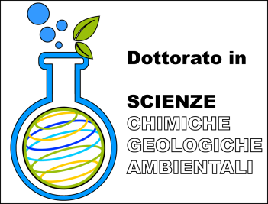**Università degli Studi di Milano - Bicocca**

**Dottorato di Ricerca in Scienze Chimiche, Geologiche e Ambientali**

***Curriculum in Scienze Ambientali***

DISCUSSIONE TESI XXXI CICLO

**Mercoledì 20 febbraio 2019**

**Aula Marchetti (edificio U1, piano terra)**

**---------- Ore 9:00 ----------**

***Ilaria Cazzaniga***

“Processing and analysis of latest generation satellite data for monitoring optically complex waters”

***Giulia Furlanetto***

“Quantitative reconstructions of climatic series in mountain environment based on paleoecological and ecological data”

***Sara Giani-Tagliabue***

“Computational approaches to study binding of

xenobiotic molecules to receptors”

***Giulia Tagliabue***

“Linking vegetation optical properties from multi-source remote sensing to plant traits and ecosystem functional properties”